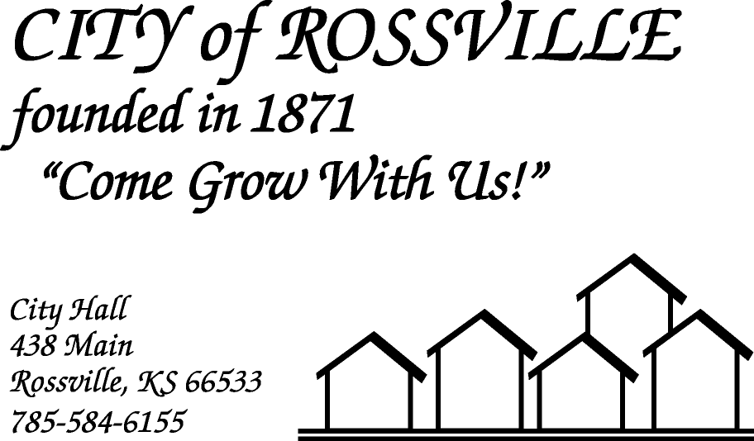

**AGENDA**

**MONDAY**

**MAY 18, 2020**

***AGENDA SUBJECT TO CHANGE***

7:00pm MINUTES

BILLS

ADOPT AGENDA

CMB LICENSE

7:05 pm COUNCIL REPORT

7:10 pm UTILITY DEPT REPORT/BUSINESS

7:20 pm POLICE DEPT REPORT/BUSINESS

7:30 pm OLD BUSINESS

Stimulus Infrastructure Priority List

7:40 pm NEW BUSINESS

Rossville Community Recreation Assoc-Summer Ball Program

7:50 pm ADJOURN

**NOTE: As City Hall is Closed to the public due to COVID-19 the meeting will be online using ZOOM meeting service**

**Meeting ID: 849 5506 7022**

**Password: 842714**

**Please call City Hall at 785 584-6155 if you need assistance.**